Task 1: Creating and Renaming Files/Directories

Create a directory named test_dir using mkdir.

Inside test_dir, create an empty file called example.txt.

Rename example.txt to renamed_example.txt using mv

Solution:

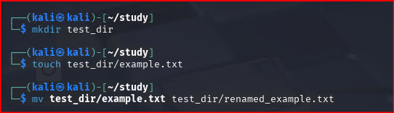

Task2: Viewing File Contents

Use cat to display the contents of /etc/passwd.

Display only the first 5 lines of /etc/passwd using head.

Display only the last 5 lines of /etc/passwd using tail.

Solution:

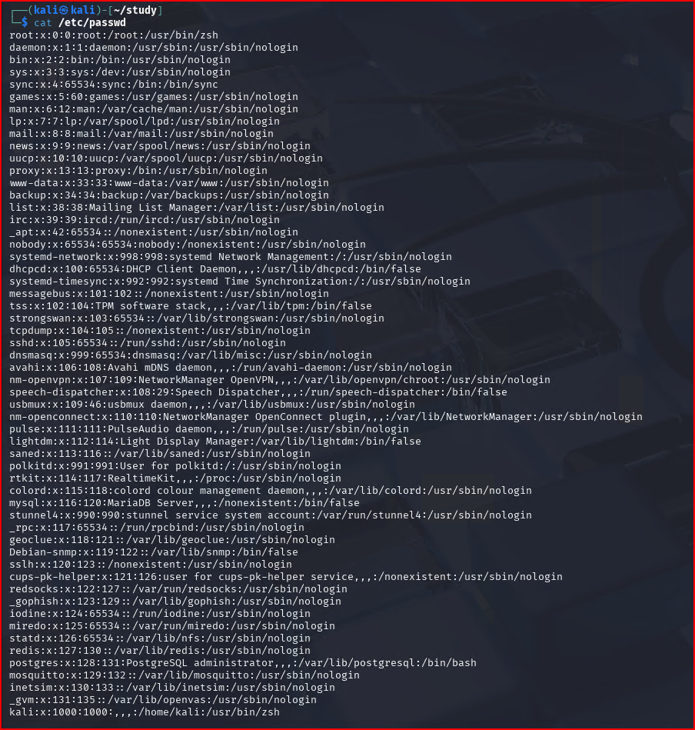

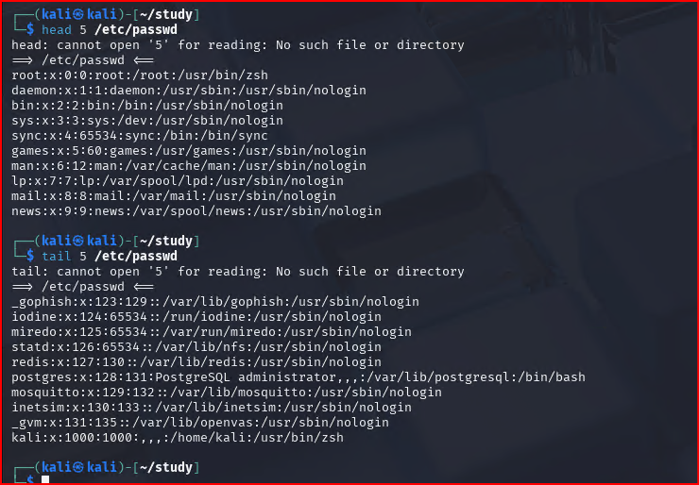

Task3: Searching for Patterns

Use grep to find all lines containing the word "root" in /etc/passwd.

Solution:

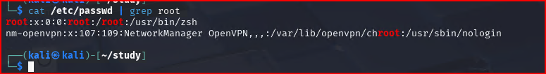

Task4: Zipping and Unzipping

Compress the test_dir directory into a file named test_dir.zip using zip.

Unzip test_dir.zip into a new directory named unzipped_dir.

Solution:

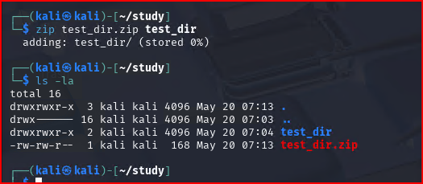

Task5: Downloading Files

Use wget to download a file from a URL (e.g., <https://example.com/sample.txt>).

Solution:

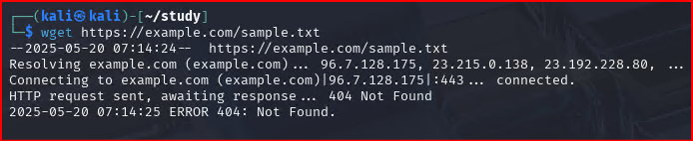

Task6: Changing Permissions

Create a file named secure.txt and change its permissions to read-only for everyone using chmod.

Solution:

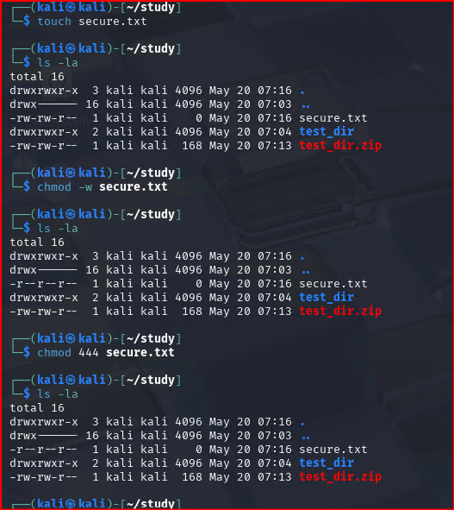

Task 7: Working with Environment Variables

Use export to set a new environment variable called MY_VAR with the value "Hello, Linux!".

Solution:

